Prerequisites

- OS windows 7 Sp1, Windows 8, Windows 10
- RDP Version 8.1

Follow these steps to verify that you have upgraded to RDP version 8.1
- Open Remote Desktop by clicking the Start button. In the search box, type MSTSC, and then in the list of results, click Remote Desktop Connection.

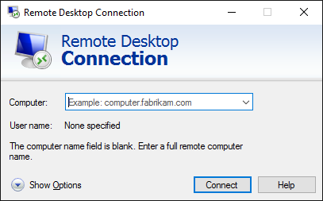

- In the top-left corner of this window, right-click the small Remote Desktop symbol.
- Select About

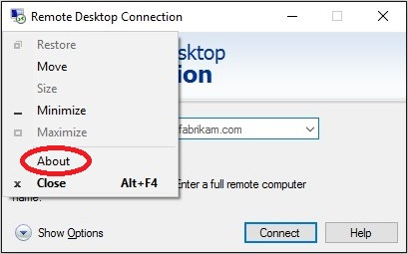

- The bottom line will say “Remote Desktop Protocol 8.1 supported.” if the upgrade was successful.
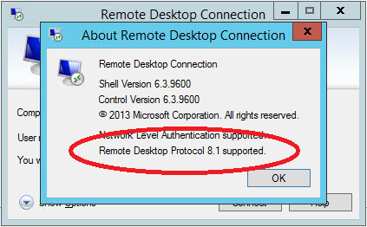

Note: If you need up gradation or troubleshooting please follow steps mentioned below in upgradation guide.

